Contents

1 Existing Report menu links go to Report pages which also have scheduling controls. 2

Requirement: 2

Proposal: 2

Proposed layouts for Periodic controls: 3

“Report schedule “End criteria” 6

“Last Sent Date” 6

Proposed screen layouts for the Report screens: 8

2 Additional fields required on Period Report screen for Org Admins 22

Requirement: 22

Proposed screenshots: 23

3 Additional fields required on Period Report screen for SALT Admins 25

Requirement: 25

Proposed screenshot: 26

4. Suspend/Delete/Transfer Reports to another user when a User is made inactive. 26

5. Allow import files to update existing users and Additional fields in import files 31

Requirement: 31

5.1 New Fields 31

5.2 Behaviour of “Update Imports” 32

6. Modifications to “My Training” page 34

Requirement: 34

Proposed modifications screens: 34

7. Provide a Rich Text editor on the existing “Org Config” screen 35

Requirement 35

Proposed Screens: 36

Requirements 36

Identified Risks 37

8. Ability to disable manager notifications at course level and to produce summaries or individual notifications. 37

8.1 Ability to disable manager notifications 38

8.2 Ability to modify notification options for each course 38

8.3 Ability to produce summaries or individual notifications. 38

8.4 Ability to produce summaries at frequencies other than one day. 38

9. Provide a feature that allows org admins to temporarily stop all emails for their org. 38

10. Replace the user of the word “Delinquency” or “Delinquent” with a more appropriate word. 39

Requirement 39

11. reports are grouped by category 39

Requirements 39

Implementation 40

Testing 40

# Existing Report menu links go to Report pages which also have scheduling controls.

Requirement: Allow org admins to create/define periodic reports (for all reports implemented as Reporting Services Reports) from the same screen as the manual reports.

## Proposal:

Users will create Report Schedules by clicking on the existing Report Menu links which will display a page which is ‘identical’ to the existing Report page however it will have additional controls located at the bottom of the page that allow the user to have the Report delivered a number of times (at a predefined Schedule) via Email.

Some screens may have minor changes (see Licensing Report page as this has been altered the most) – mostly in the height of the Course List – see actual screenshots for exact details.

Please note that Users will also be able to generate Periodic Reports by clicking on the New button. For example, the Summary Report Screen by pressing the ‘New’ button on the ‘Periodic Report screen’ and selecting ‘Summary Report’ (in this way new Reporting Services Reports may be added to SALT without needing to create a link in the Report Menu).

Report Schedules will be owned by a single individual and that individual is the only Recipient on the TO: list

When the Report Schedule is made inactive or the owner of the Report is made inactive the Report Schedule does not send any Reports via email until both the Schedule and the Owner of the Schedule are made active.

A Report schedule may have several CC: recipients, when a CC: recipient is inactive the other recipients will continue to receive the Reports via Email however the inactive Recipient/s will not receive the report.

Report Schedules may be given a name to identify different schedules in the users list of schedules (For example ‘Quarterly Progress Summary’ or ‘Daily Progress Summary’) however the name of the Schedule does not appear in the Email that contains the Report. (The Report that is sent would typically contain a localised Report Title and DateFrom and DateTo fields)

## Proposed layouts for Periodic controls:

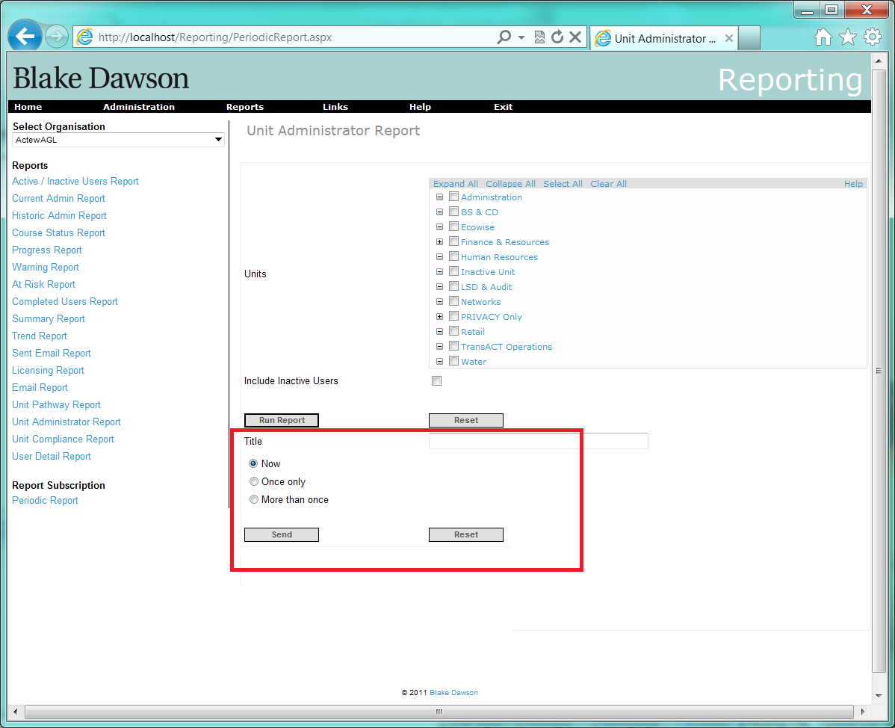

Figure 1 “NOW”

The “Run Report” button will behave as it does now, it will render the Reporting Services Report in a panel that provides a toolbar containing pagination and exporting controls.

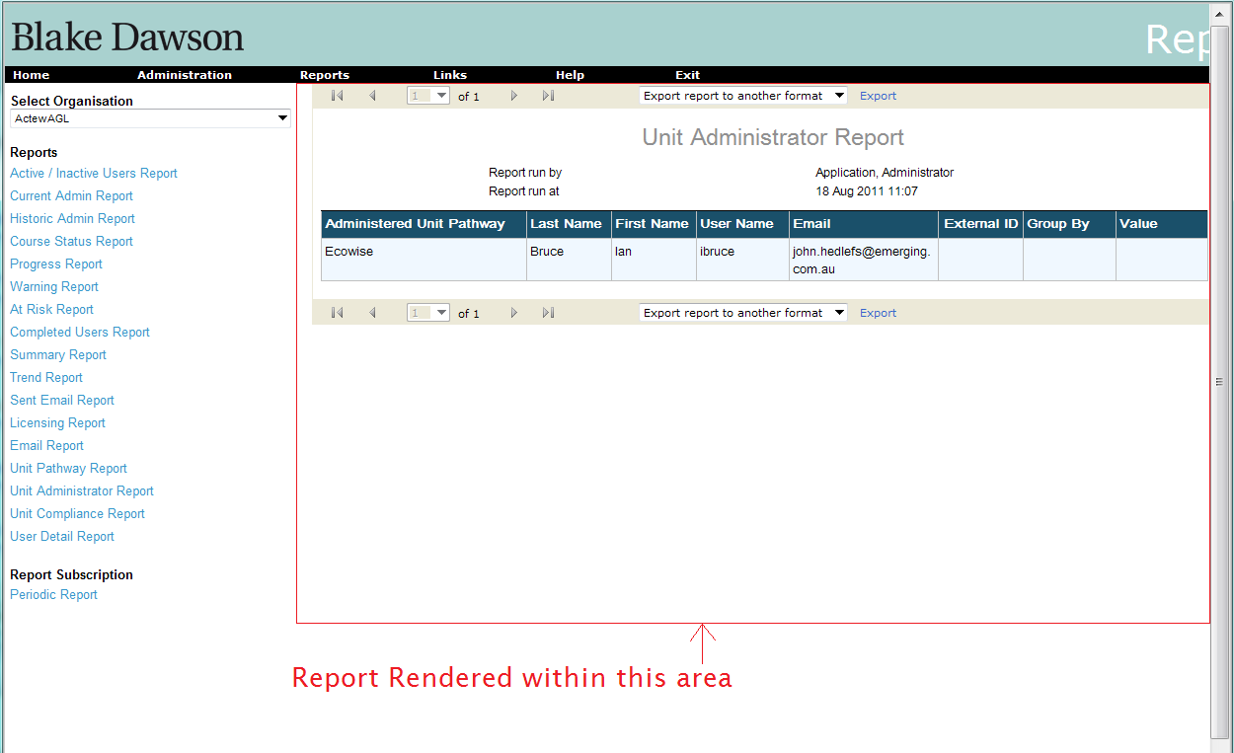

Figure 2 The area in which the “Reporting Services” report will be rendered

The “Reset” button beside the “Run Report” button will clear the values from all of the controls above this “reset” button.

The “Now”-“Once Only” – “More than once” RadioButtonList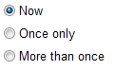will show/hide additional controls as per figures 1, 3 and 4

When “Now” is selected and the “Send” button is pressed a request to email the Report to the Report owners email address (and any other additional recipients selected as CCc) at the earliest moment possible will be queued. (A one-off Report Schedule will be created and will be processed based on relevant rules relating to priorities of Reporting Services Emails vs user webpage requests etc and any other devices such as “Stop mail” controls on mail throughput screens. The Report Schedule will not appear on any list of schedules. When the Report Schedule is processed it will be deleted. If the Reports Recipient is flagged “Inactive” at the time of processing the Schedule will be deleted without any emails being raised) The “Title” field is ignored when the “Now” RadioButton is selected – i.e. it is not saved and never appears on any emails. When a schedule is deleted no record is kept of the schedule ever having existed (for audit purposes).

When “Once only” is selected a date control is displayed and this date control must be populated before the “Send” button can be pressed (validation behaves as per all existing controls). When the “Send” button is pressed a request to email the Report to the Report owners email address (and any other additional recipients selected as CCs) at 00:00:00 in the Organisations Timezone on the day selected in the date control be queued. (A once-off Report Schedule will be created and will be processed based on relevant rules relating to priorities of Reporting Services Emails vs user webpage requests etc and any other devices such as “Stop mail” controls on mail throughput screens. The Report Schedule will appear on lists of schedules. When the Report Schedule is processed it will be deleted. If the Reports Recipient is flagged “Inactive” at the time of processing the Schedule will be deleted without any emails being raised) The “Title” field becomes the “Report Title” of the Report Schedule when the “Once Only” RadioButton is selected – i.e. it is saved as the “Report Title” of the Report Schedule however it never appears on any emails. When a schedule is deleted no record is kept of the schedule ever having existed (for audit purposes).

When “More than Once” is selected the following controls will appear:

* A “Start date” date control
* A “No end Date”-“End after”-“End On” RadioGroupList of buttons
* A “Number of reports” text box (and label)
* An “End on” date control
* A “How often” text edit control and a listbox containing (localized versions of) “day”,”week”, “month” and “year”.

The “Start date” date control and the “How Often” control must be populated before the “Send” button can be pressed (validation behaves as per all existing controls).

When the “No end date” option is selected no further controls need be populated and the Report Schedule can be saved when the “Send” button is pressed.

When the “end after” option is selected the user must populate the “number of reports” textbox with a positive non-zero integer before saving the Report Schedule.

When the “end on” option is selected the date control beside the “end on” option must be populated before saving the Report Schedule.

When the “Send” button is pressed a request to email the Report to the Report owners email address (and any other additional recipients selected as CCs) as soon as possible after 00:00:00 in the Organisations Timezone (after the overnight job has been run for that Organisation)on the day selected in the “Start date” control be queued. (A repeating Report Schedule will be created and will be processed based on relevant rules relating to priorities of Reporting Services Emails Vs user webpage requests etc and any other devices such as “Stop mail” controls on mail throughput screens. The Report Schedule will appear on lists of schedules. When the Report Schedule is processed it will not be deleted (unless it has met its “end criteria” – see below). If the Reports Recipient is flagged “Inactive” or the Report is Flagged as inactive at the time the Schedule should have been processed then the “Last Sent Date”, “Date From” and “Date To” are moved forward by amounts (defined below) appropriate to the “How often” ,“Date From” and “Date To” controls so that the next time a User examines the schedule the “Date From” and “Date To” controls will show the correct values for the next time the Report is to be sent. The “Title” field becomes the “Report Title” of the Report Schedule when the “More than once ” RadioButton is selected – i.e. it is saved as the “Report Title” of the Report Schedule however it never appears on any emails.

### “Report schedule “End criteria”

When SALT processes a schedule (sends emails to the active recipient and any CC: addresses) it records how many times the Report has been sent (it increments the “Number of times Report sent” counter) and the date that it was last sent (see note below) and examines the schedule “end on” or “end after” criteria to determine if the schedule has completed and should be deleted. When a schedule is deleted no record is kept of the schedule ever having existed (for audit purposes). If the user has specified “end after” N reports the schedule is deleted after that many reports **have been sent**, If an “end on” date has been specified the Report schedule will be deleted at (or as soon as possible after) Midnight on that date, and no reports will be generated after that date for that schedule.

### “Last Sent Date”

The date saved as the “Last sent Date” will be the “Start Date” plus the integer number of periods (say months if 1 month is selected) that have elapsed before the date the Report was actually sent.

For example:

* if the Report start date is ‘31 Jan 2011’ but the Report is not sent until ‘1 Feb 2011’ then the “Last Sent Date” will be recorded as “31 Jan 2011’ (startdate plus zero months)

if the Report start date is ‘31 Jan 2009’ but the Report is not sent until ‘1 Feb 2011’ (the Report Service may have been disabled for some time) then the “Last Sent Date” will be recorded as “31 Jan 2011’ (startdate plus 24 months) (Please note that the “Last Sent Date”, “Date From” and “Date To” are always moved forward **together** by amounts (defined below) appropriate to the “How often” ,“Date From” and “Date To” controls - so in this case the “Date From” and “Date To” controls will also be advanced by 24 times the amount they would have advanced in a single Report Cycle.) The GUI (Periodic Reports Webpage) will only display values for the “How often” ,“Date From” and “Date To” controls as they appear in the tables so that if the “Report Sending Service” is not running and advancing the Schedules then the values displayed by the GUI could be for dates in the past.(If the GUI did automatically advance the “Date From” and “Date To” controls before displaying them and the user were to make a minor change to a Report schedule that was scheduled to be sent moments before the user started to edit the schedule then it is possible that the Report may not be sent (this cycle) as the webpage would save the new values of “Date From” and “Date To”(that had been advanced by the webpage).

When a schedule is saved the next date that the Report should be delivered on will be calculated and stored (in this document this date will be referred to as the “Next Run Date” , when the “current date” exceeds the “Next Run Date” the “Next Run Date” will be moved forward by the “How often” period and the report will be delivered (if the reports owner is Active).

“Date From and Date To” fields (also Historic date and Effective date fields) will be incremented (every time the “Next Run Date” is incremented in the same way if the period is for an entire month – add rules for periods other than a month

The “Reset” button beside the “Send Report” button will clear the values from all of the controls between the ‘Run Report’ and ‘Send’ buttons.

Figure 3 “ONCE ONLY”

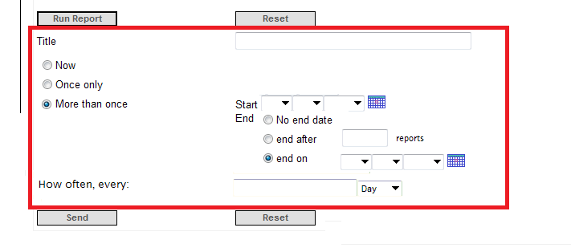

Figure 4 “REPEATED”

A CC: field will also be visible (just above the “Send” button), the control will appear as the CC: field on an Email in outlook however when the user enters the CC: field (sets focus on that control) a list of ALL Active Unit Admins and Active Org Admins for the Organisation (plus Inactive Admins that are currently CC: recipients) with checkboxes will be displayed:

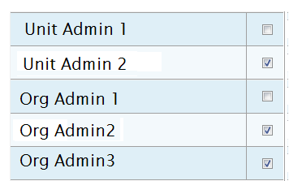and the user can select which admins are selected as CC recipients (Inactive Admins will be listed in grey text or will have the word Inactive appended to their names to indicate their status) In this way SALT is able to ensure that Reports are not sent to the email addresses in the CC: list that belong to INACTIVE users.

(note that on the day the message is actually sent the application should only send the Report to ACTIVE recipients who currently have permission to Administer the Units contained in the Report, Recipients that have permission to Administer only SOME of the Units contained in the Report will not receive any version of the Report)

## Proposed screen layouts for the Report screens:

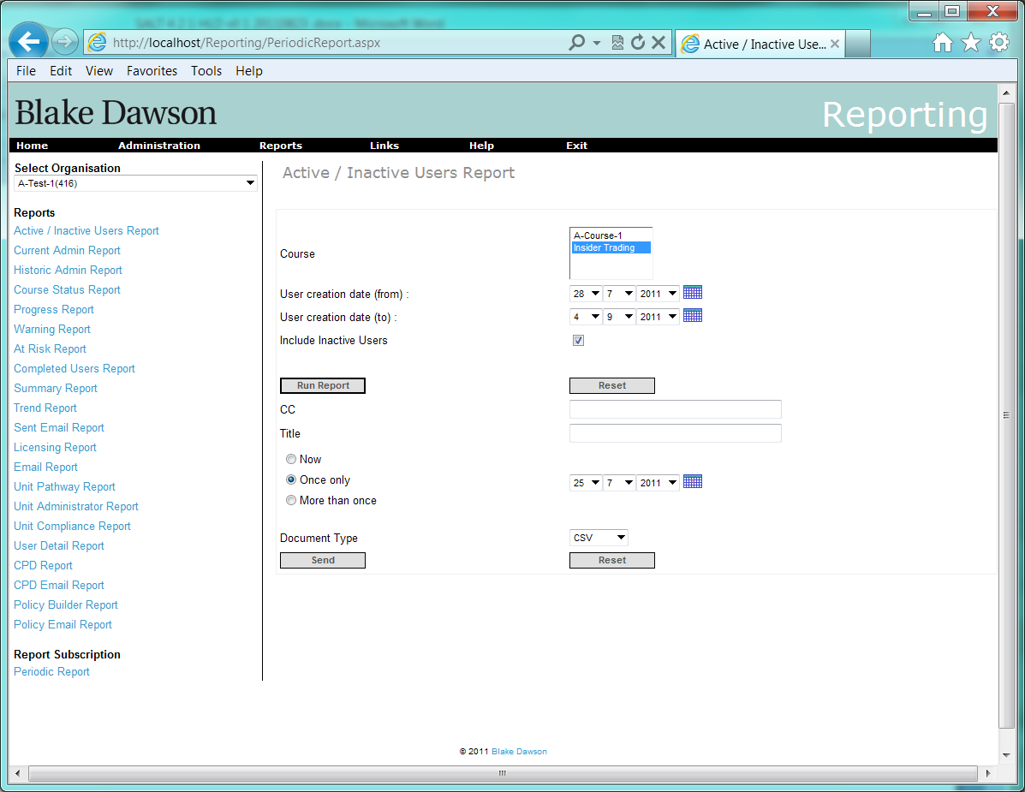

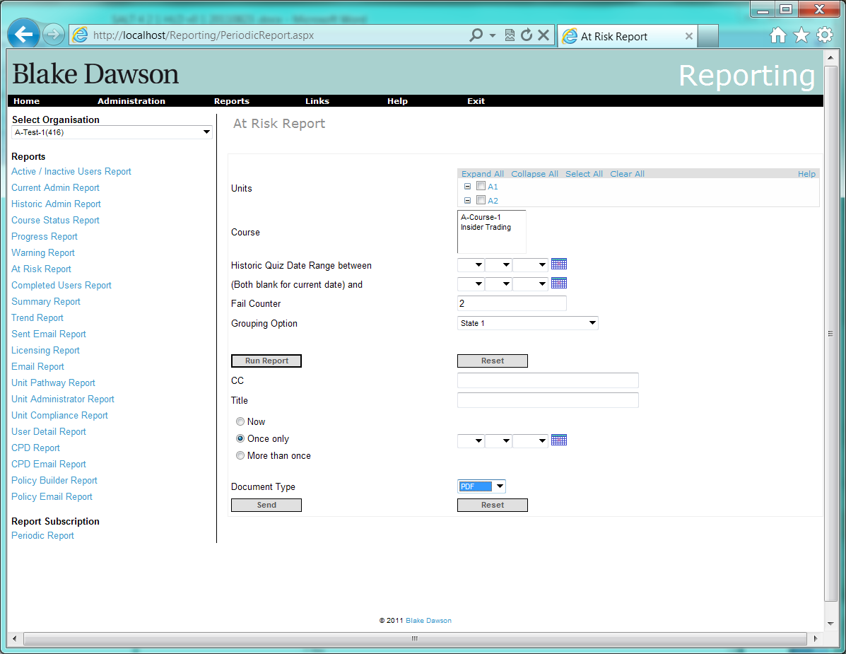

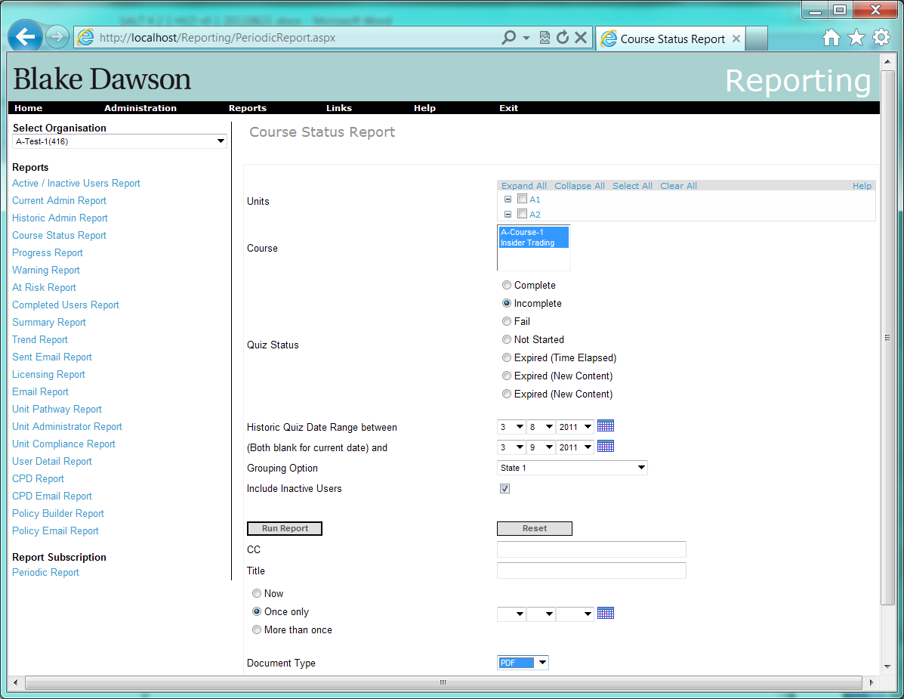

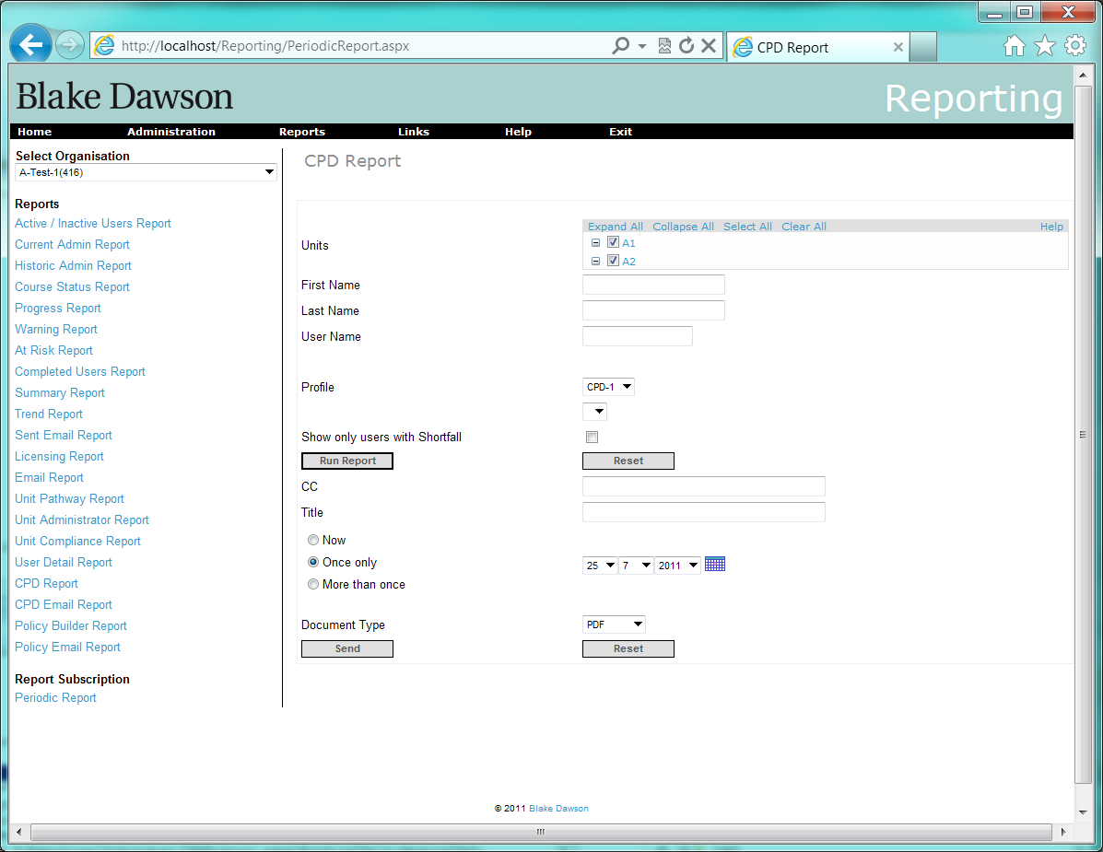

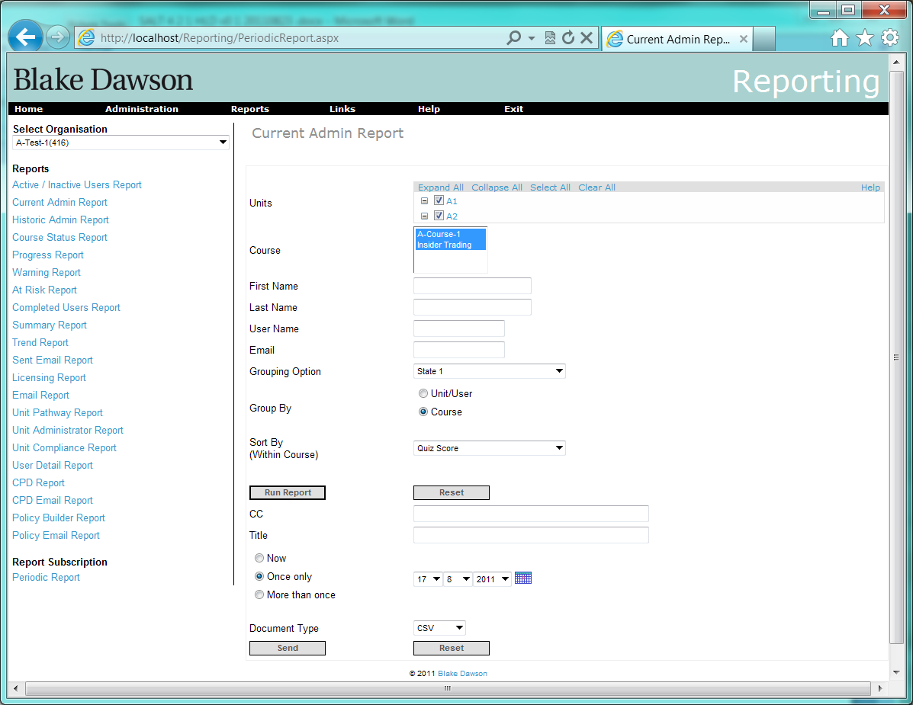

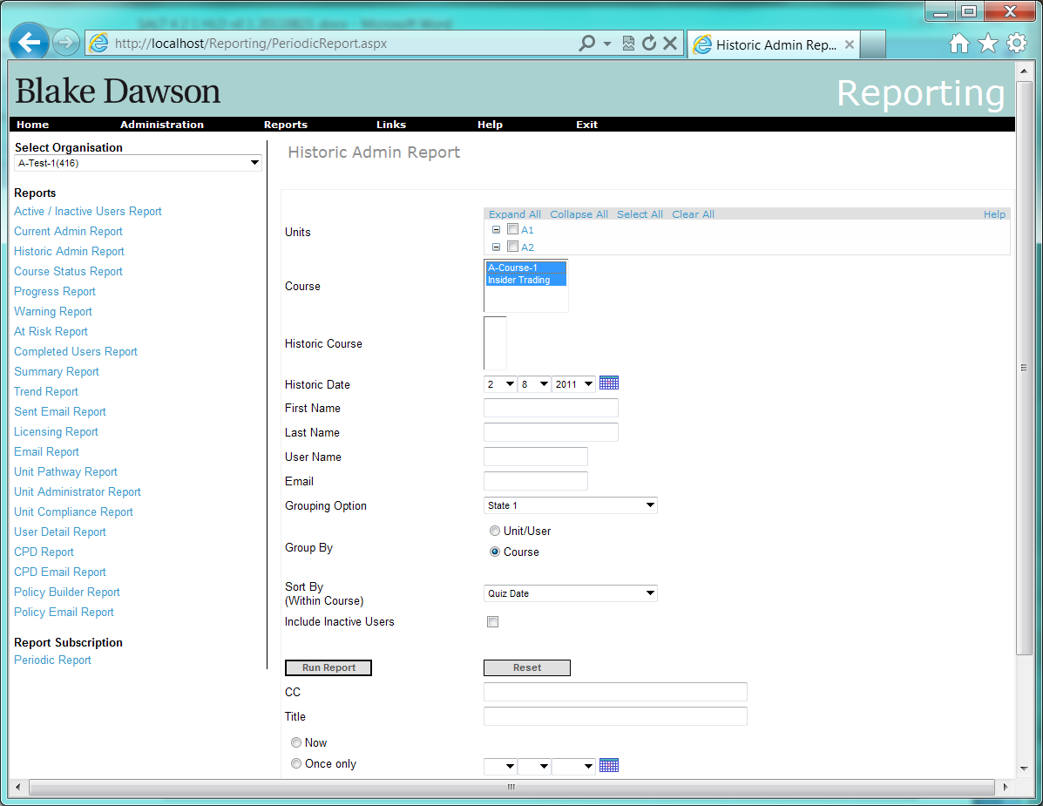

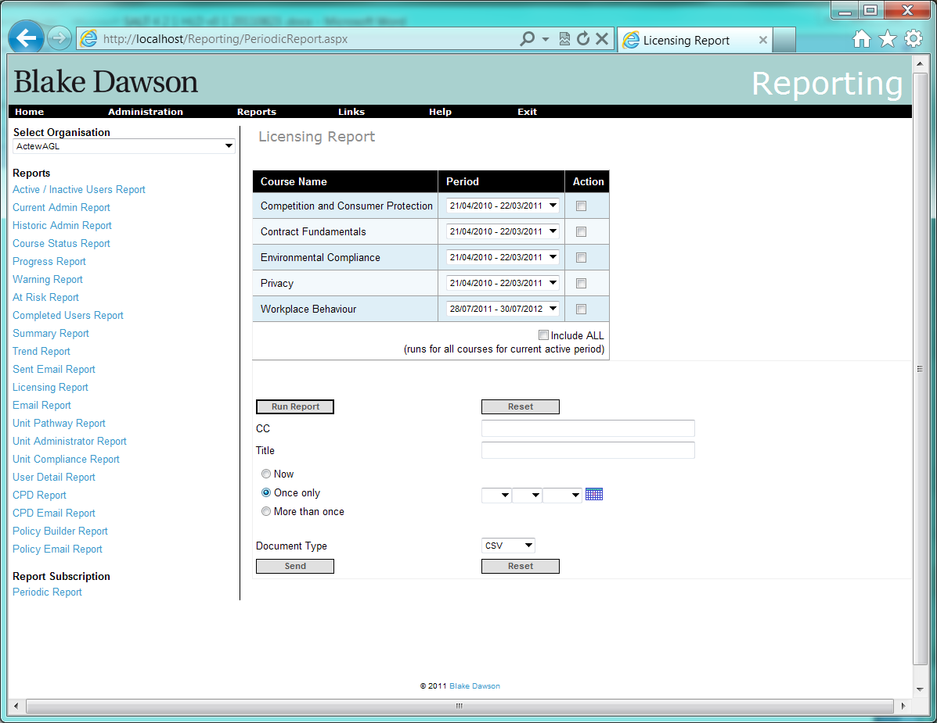

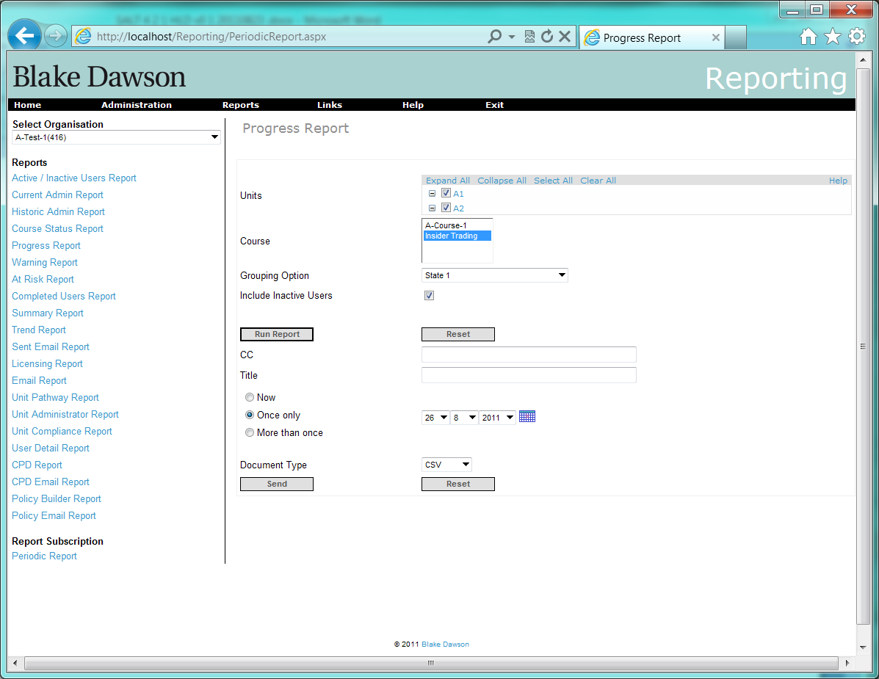

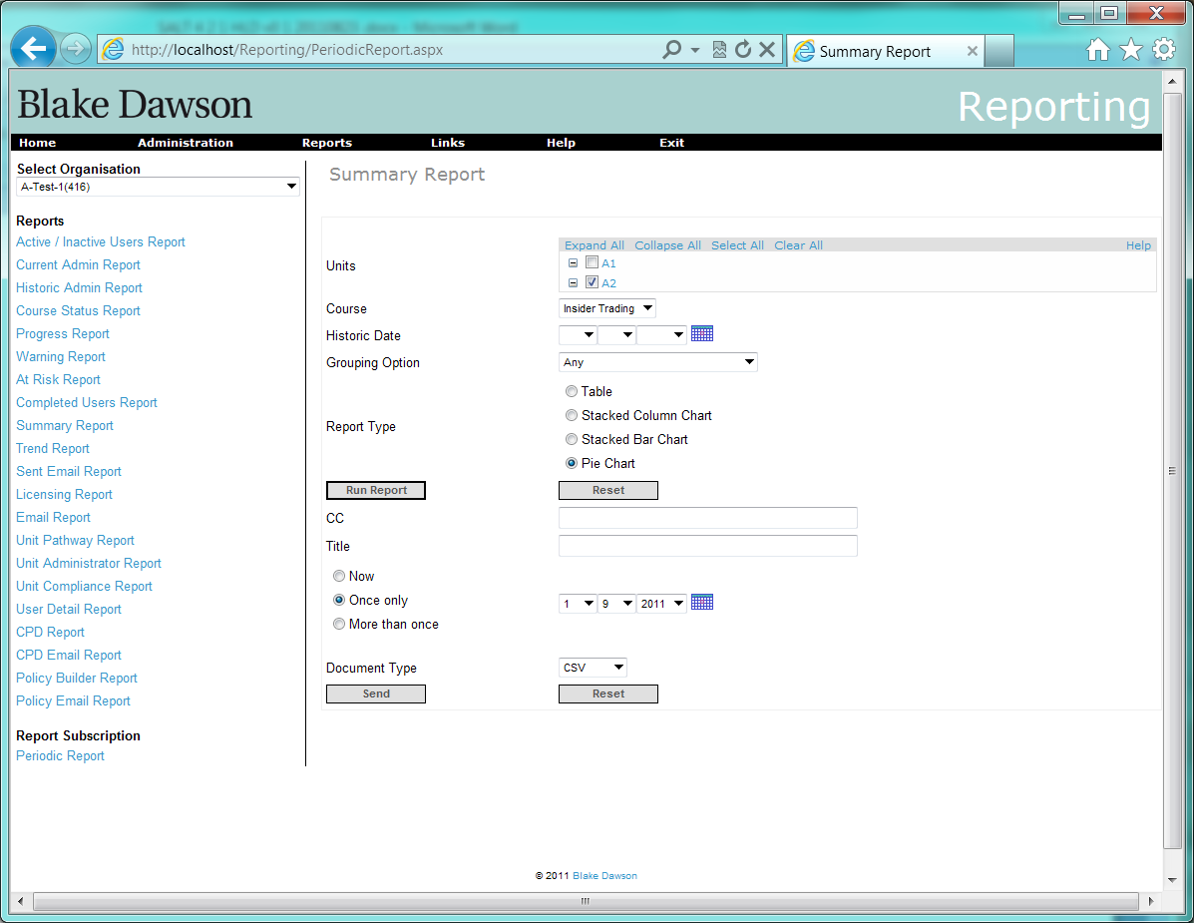

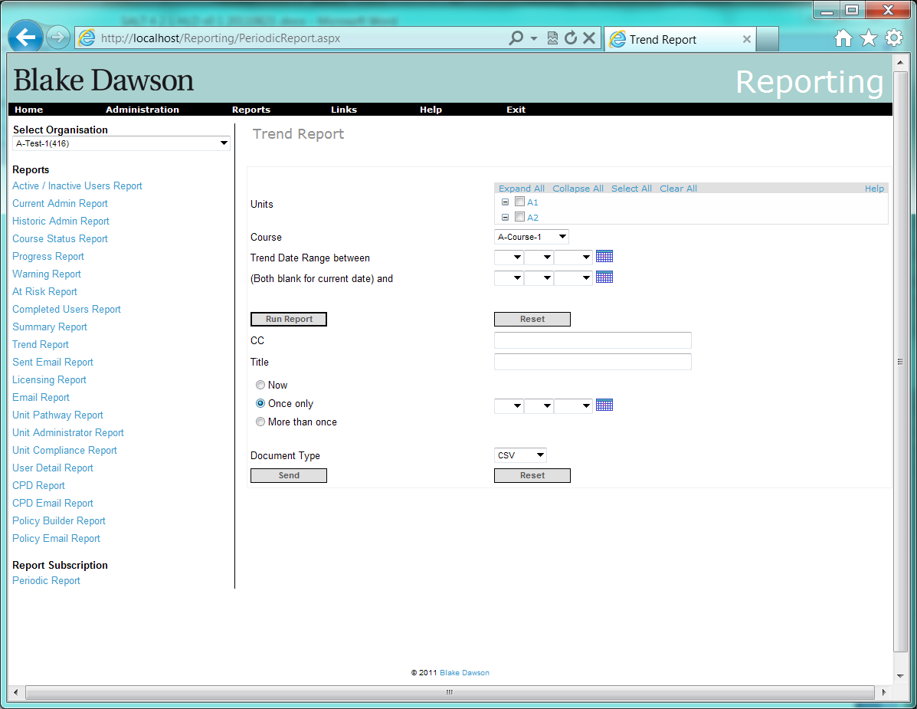

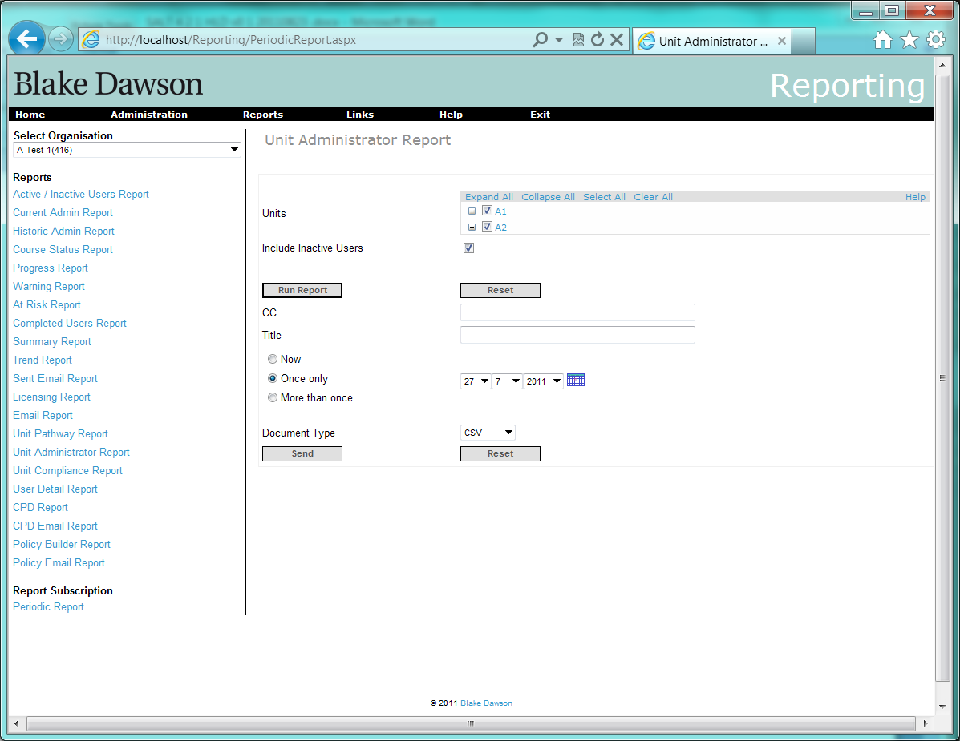

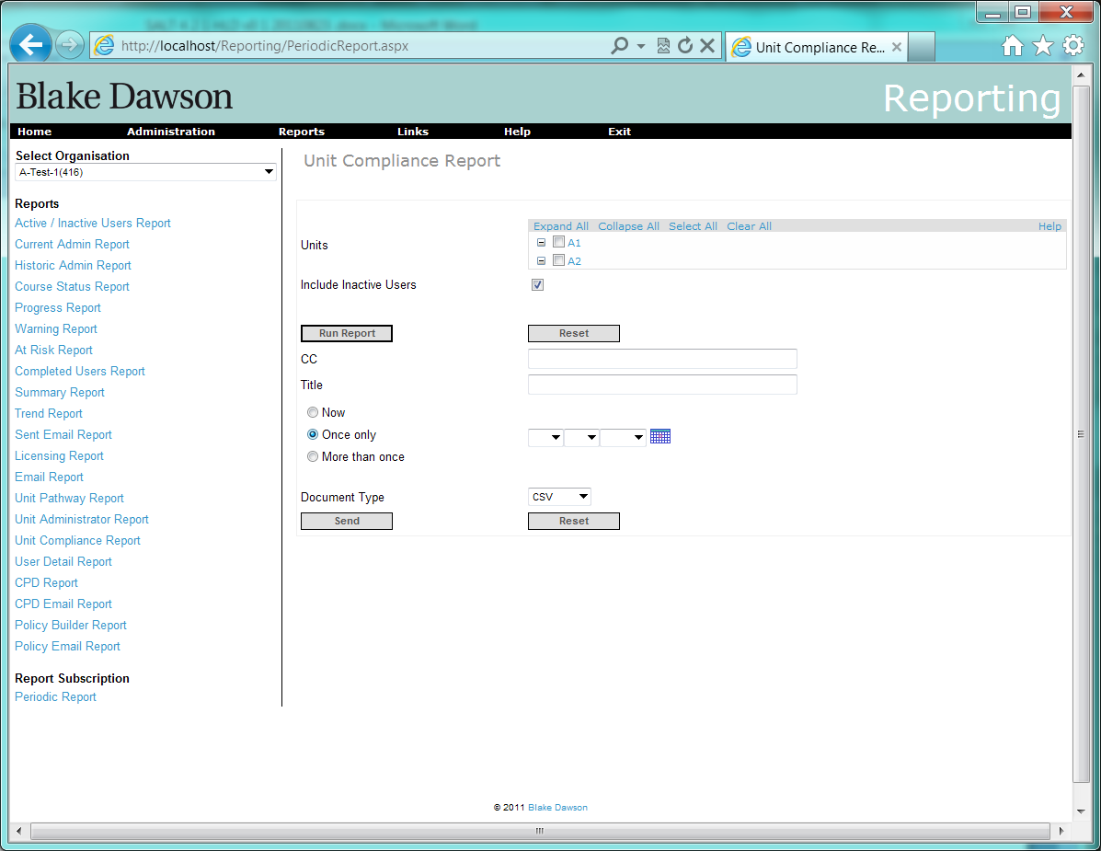

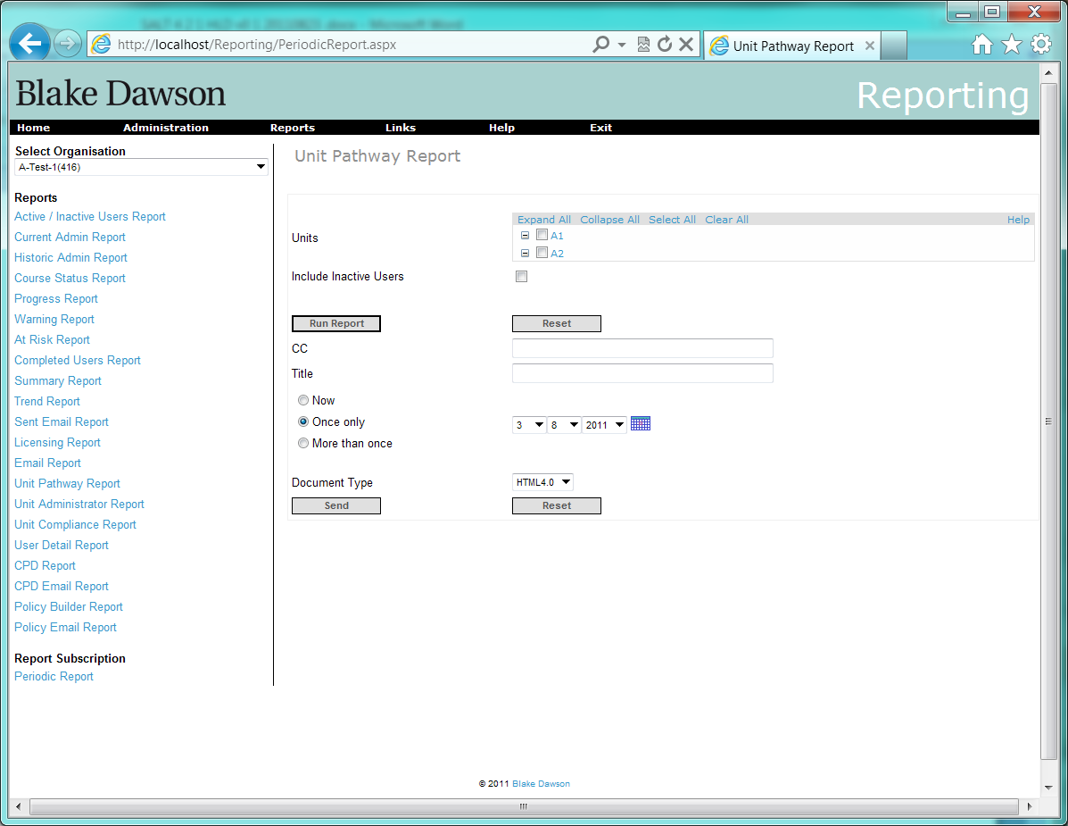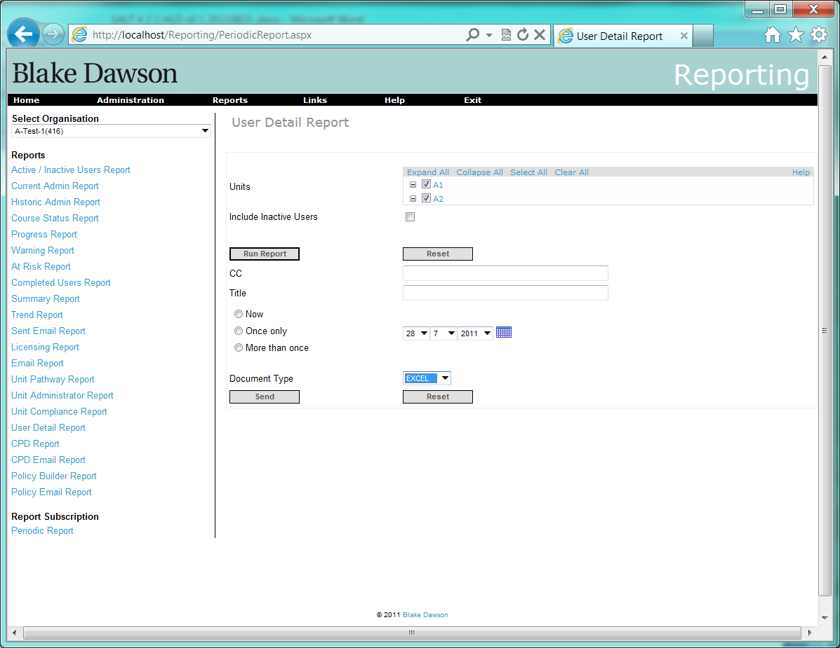

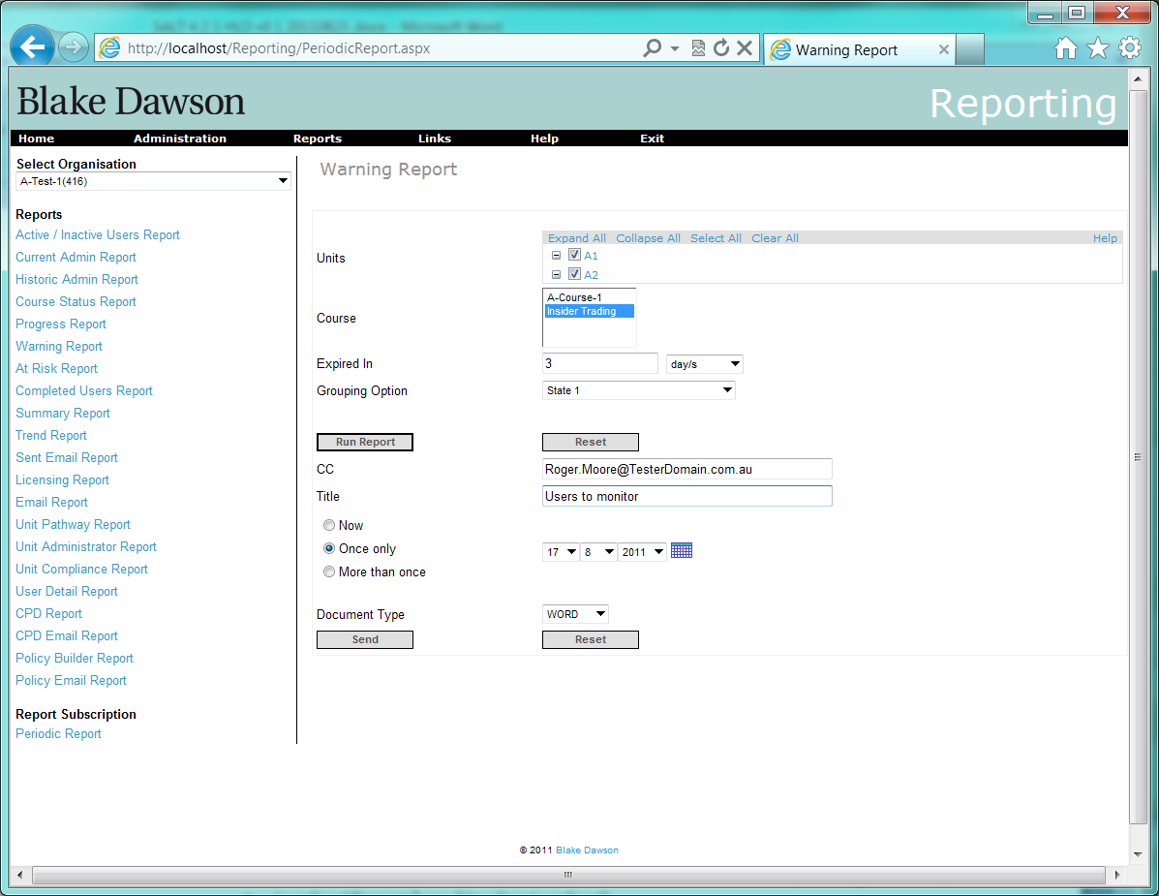

# 2 Additional fields required on Period Report screen for Org Admins

Requirement: Change the functionality of the new “Periodic Report Delivery” screen so that it provides the following features:

2.1 For an Org Admin a list of the periodic reports created by the current org admin that contains the following columns:

* Non localised Report Title entered by user in users character set (Heading Localised)
* Localised Report Type (Heading Localised)
* Localised Report Frequency (Heading Localised)
* Date Created dd mmm yyyy (Heading Localised)
* Report Starts on dd mmm yyyy (Heading Localised)
* Report Ends on dd mmm yyyy (Heading Localised)
* Non-localised “Report Delivered to” (Heading Localised)
* Localised “Active” flag (“Active” or “Inactive”) (Heading Localised) ?

2.2 Function to Delete/Remove selected reports

2.3 Function to Cancel/Suspend selected reports (but don’t delete)

2.4 Function to Edit/Change a selected report (should return the org admin to the original screen where the report was created, with the current params/criteria filled in – do not want to be able to edit the selected report on the “Periodic Report Delivery” screen)

2.5 Function to Search/Find/Filter the periodic reports by recipient (i.e. find all reports that are being sent to a particular person)

## Proposed screenshots:

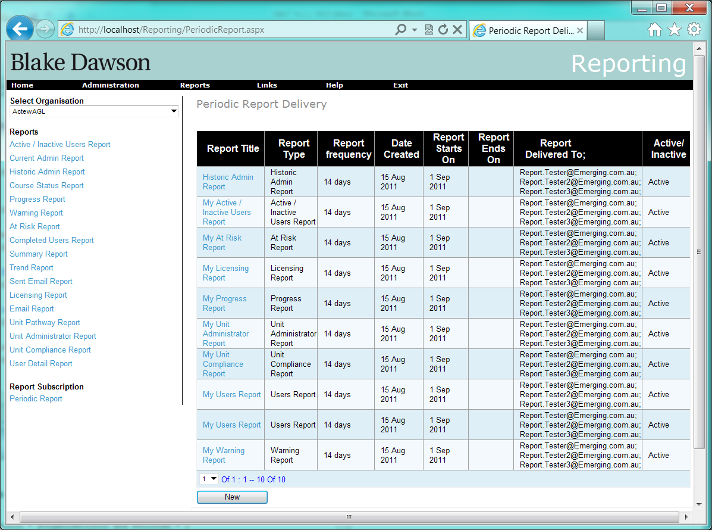

Figure 5 Period Report page (No Report Selected)

When a user selects a row the following buttons will appear:

Edit

Delete

Suspend

The edit button will take the user to the same Report screen as they would see if they navigated through the Report menu (i.e. the screen they created the report from)

The Delete button will permanently delete the Report Schedule (no record of deleted schedules will be kept.

The suspend button will flag the report as inactive (or make it active if it was inactive)

Pressing the new button will cause a “Report name” control to appear:

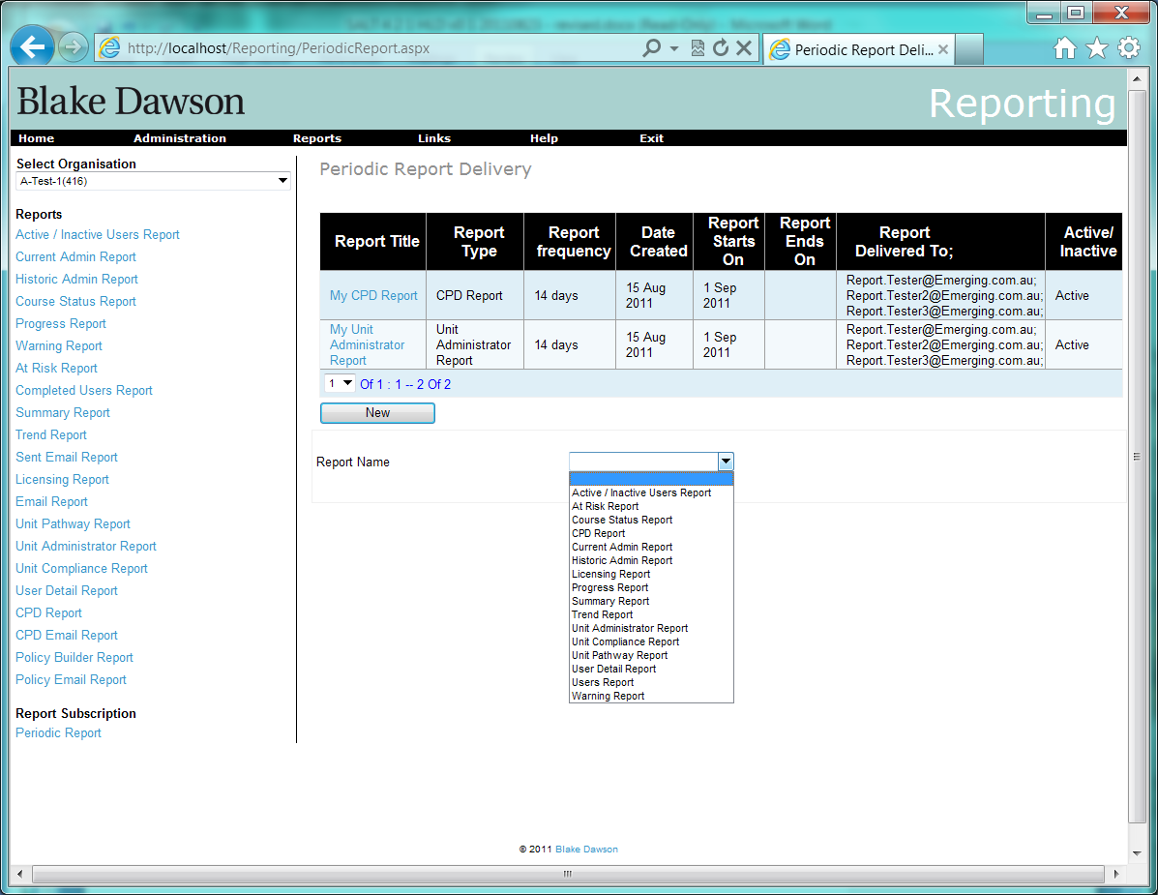

The Report Name control will be populated with the name of all Reports that the Administrator would have access to for this Organisation ( in alphabetical order).

When the user selects a Report they will be taken to the Report Screen that they would see if they navigated through the Report menu.

Org admins will not see report schedules for other org admins or unit admins?

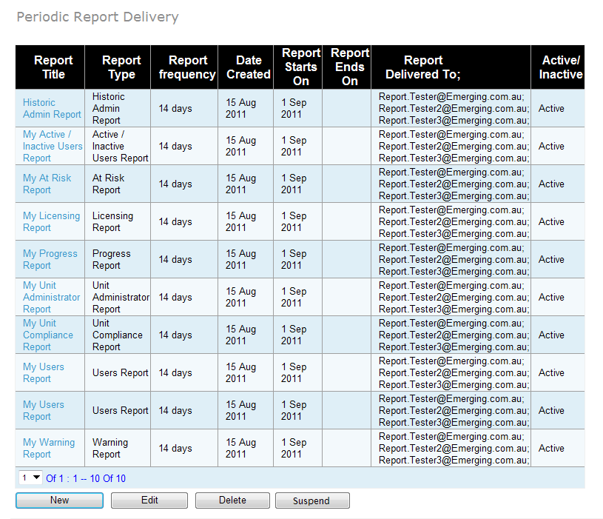

Figure 6 Periodic Report page for Org Admin (Report selected)

# 3 Additional fields required on Period Report screen for SALT Admins

Requirement: Change the functionality of the new “Periodic Report Delivery” screen so that it provides the following features:

3.1 For a SALT Admin a list of the periodic reports created by all org admins (so the salt admin can “manage” periodic reports if an org admin leaves or changes) that contains the following columns:

* Non localised Report Title entered by user in users character set (Heading Localised)
* Localised Report Type (Heading Localised)
* Localised Report Frequency (Heading Localised)
* Date Created dd mmm yyyy (Heading Localised)
* Report Starts on dd mmm yyyy (Heading Localised)
* Report Ends on dd mmm yyyy (Heading Localised)
* Report Owner (Heading Localised)
* Non-localised Administrator type (O = Organisation Admin, U = Unit Administrator) (Heading Localised)
* Non-localised “Report Delivered to” (Heading Localised)
* Localised “Active” flag (“Active” or “Inactive”) (Heading Localised)

## Proposed screenshot:

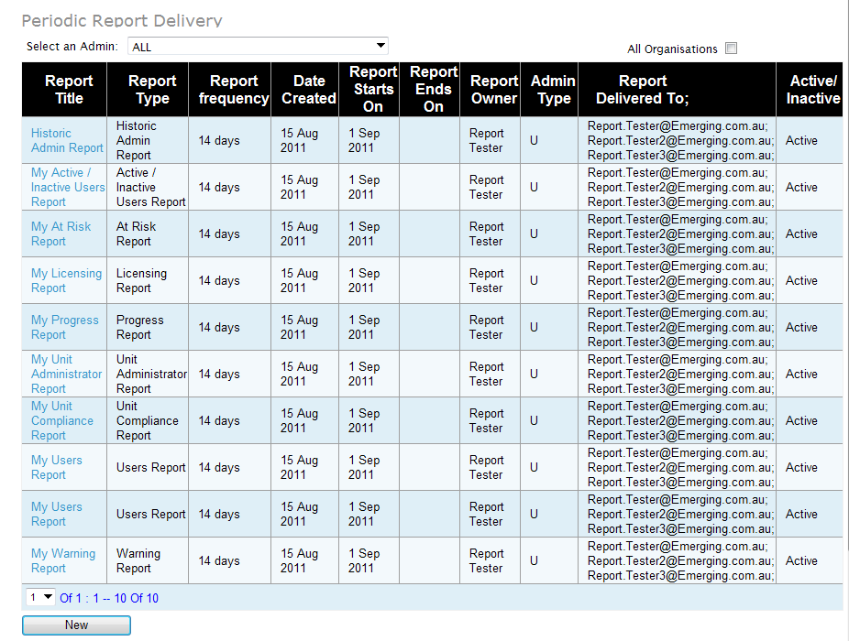

Figure 7 SALT Admin Periodic Report page (No Report selected)

# 4. Suspend/Delete/Transfer Reports to another user when a User is made inactive.

**Requirement:**

The admin should be notified that the inactive user was either the owner of (in the case of an org admin) or a recipient of the following periodic reports.  The admin should then be given the following choice for each periodic report that relates to the inactive user:

* + Suspend the report if the inactive user was the owner of the report (i.e. the report is suspended, but, not Deleted), or remove the inactive user from the list of recipients (i.e. the report continues to run, and the remaining recipients will continue to receive it).
  + Reassign the report to another user.  If the inactive user was the owner of the report, then the selected replacement user will become the new owner.  If the inactive user was just a recipient of the report, then the selected replacement user will now receive the report instead of the inactive user (other recipients remain unchanged).
  + Delete the schedule (a Record of deleted schedules will be kept however there will be no way to view deleted schedules at this time)

There are 7 (identified) circumstances when a user’s reports may be required to be transferred to another user, suspended or deleted:

* + 1. At the time a user is made inactive (archived) from the User Details screen.
    2. At the time that the users replacement is entered into the system (may be much later after the user is made inactive) from the New User screen.
    3. At the time that the users replacement is entered into the system (may be much later after the user is made inactive) from an import (CSV or XML).
    4. When a group of users are made inactive (archived) from the Archive Users screen.
    5. When a group of users are made inactive due to an import (CSV or XML)
    6. When a SALT administrator performs maintenance on reports (to inactive users) (for example Reports that were not transferred to the user’s replacement).
    7. At such other time that a SALT administrator needs to maintain an Organisations Scheduled Reports.

There are 3 webpages where an admin can make a user inactive:

* Make a single user inactive in the “User Details” screen
* Make bulk users inactive in the “Archive Users” screen
* Make bulk users inactive at import of users
  1. On the “User Details” screen, when the admin unchecks the “User Active” checkbox and clicks “Save” button, a new screen (shown below) is displayed asking if periodic reports associated with this user should be modified.

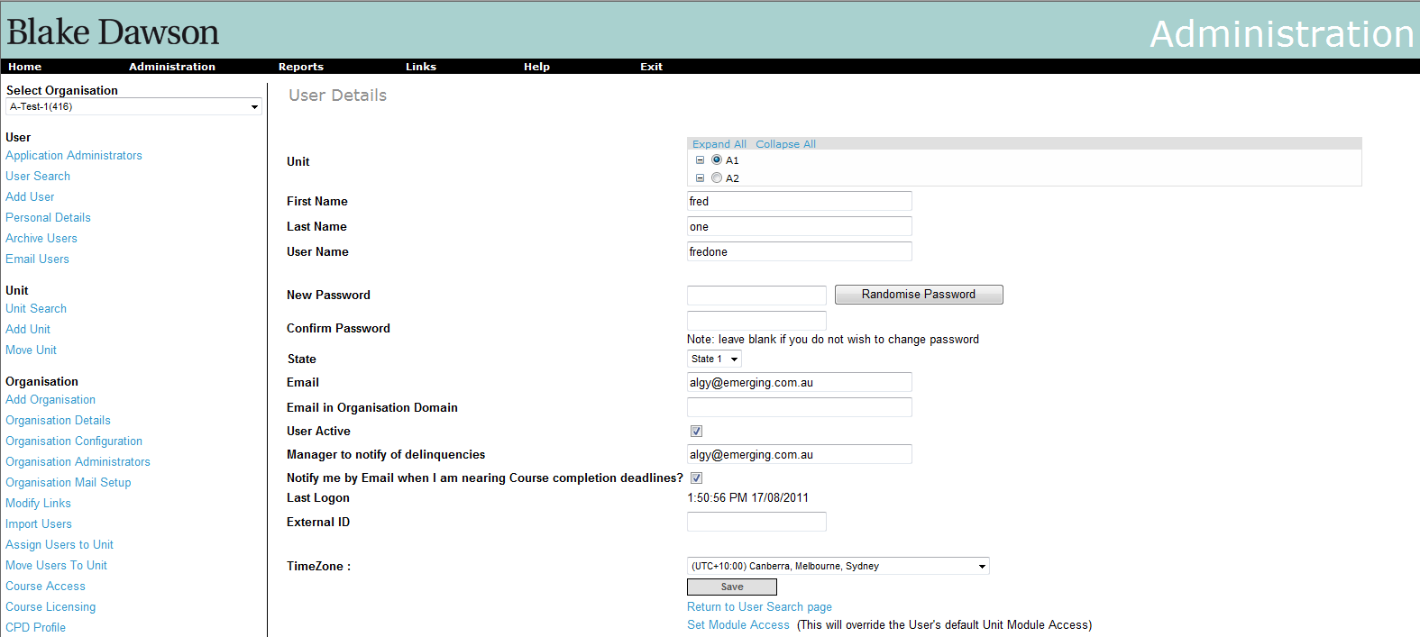

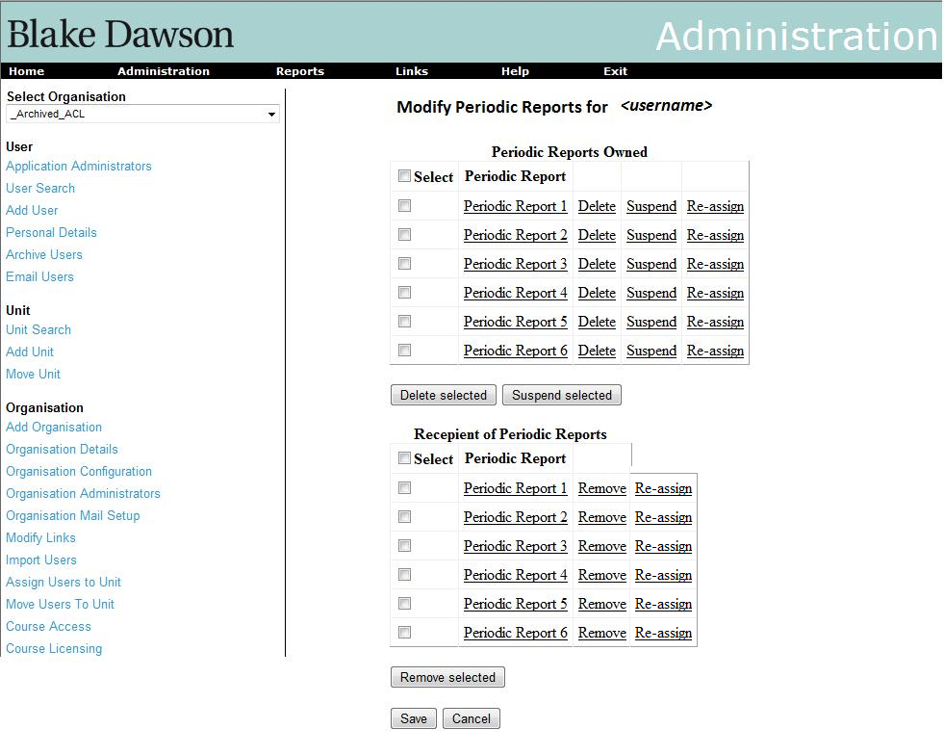

2 tables will be displayed on this page as shown in the figure above. The top table will show the periodic reports that are owned by this user. There are “Delete”, “Suspend”, and re-assign buttons against each report. The admin can deleted this report, suspend it for the time being or reassign the report using these buttons respectively. The admin can also select multiple reports and delete or suspend them all by using the “Delete selected” or “Suspend selected” buttons at the bottom of the table respectively.

The bottom table shows the periodic reports for which the user is a recipient. There is a “Remove” and reassign button against each of these reports for the admin to remove this user from the recipient list of this report. The admin can select multiple reports and remove the user from the recipient list of these selected reports by using the button “Remove Selected” at the bottom of the table.

At the bottom of the screen there are buttons to save these changes or cancel the changes made and return to the “User Search” page.

* 1. On bulk archiving the users, the following screen will be shown to the admin:

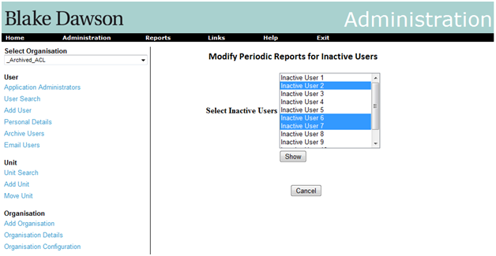

The listbox for “Select Inactive users” will be populated with the inactive users that have been archived by admin on the “Archive Users” screen. The admin can then select inactive users from this listbox and click “Show” button. This will display the 2 tables as shown below.

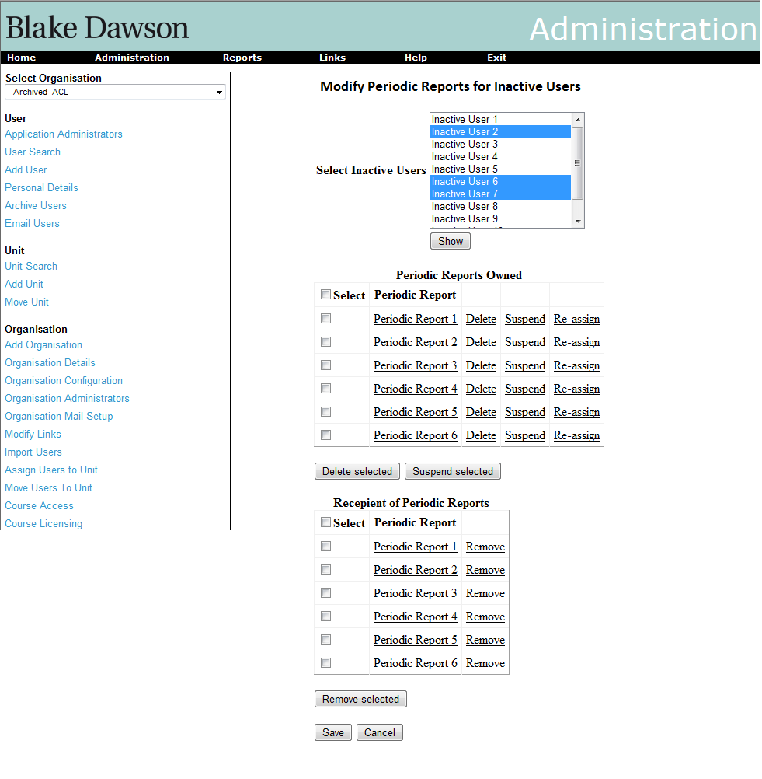

The functionality of these tables will be the same as explained in section 4.1. The only difference in this case will be that it will contain periodic reports for all the selected users in the listbox above.

* 1. For bulk import of users too, the same screens in section 4.2 will be shown. However, in this case the listbox will contain the inactive users from the imported users list.

# 5. Allow import files to update existing users and Additional fields in import files

Requirement: Provide a bulk update feature for user imports that will allow org admins to change user values en masse without affecting existing values (i.e. update the manager’s email address for a group of users, but, don’t change anyone’s password, or give a group of users new email addresses, but, don’t change their passwords, or give a group of user new passwords, but, don’t update their email addresses, etc.).

5.1 New Fields:

* Unit Administrator
* Organisation Administrator
* Manager notification
* Manager

All of these new fields, with the exception of “Manager Notification”, specify whether delinquencies of that user be alerted by email to these roles respectively. The “Manager Notification” field contains the email id of the manager to notify.

Following is the format of CSV file that will be supported. Each of the columns here represents text that will be separated with a comma. The column names are not required to be part of the file. The columns that are greyed out are the new additions.

|  |  |  |  |  |  |  |  |  |  |
| --- | --- | --- | --- | --- | --- | --- | --- | --- | --- |
| **username** | **password** | **firstname** | **surname** | **email** | **external ID** | **unit ID** | **archive** | **group by** | **value** |
| bdawson | compliance | Blake | Dawson | [blake.dawson@bdw.com](mailto:blake.dawson@bdw.com) | 225 | 100 | 0 | Job Role | Administrator |
| bdawson |  | Blake | Dawson | |  | | --- | | blake.dawson@bdw.com | |  | 101 | 0 |  |  |

|  |  |  |  |
| --- | --- | --- | --- |
| **Unit Administrator** | **Org Administrator** | **Manager Notification** | **Manager** |
| Yes / No | Yes / No | Yes / No | =if(="Yes","Enteremailaddress",BLANK) |
| Yes / No | Yes / No | Yes / No | test.manager@testsite.com |

These fields will indicate whether the respective administrators should get the alert emails or not.

The preview will show the new fields for as per the screenshot:

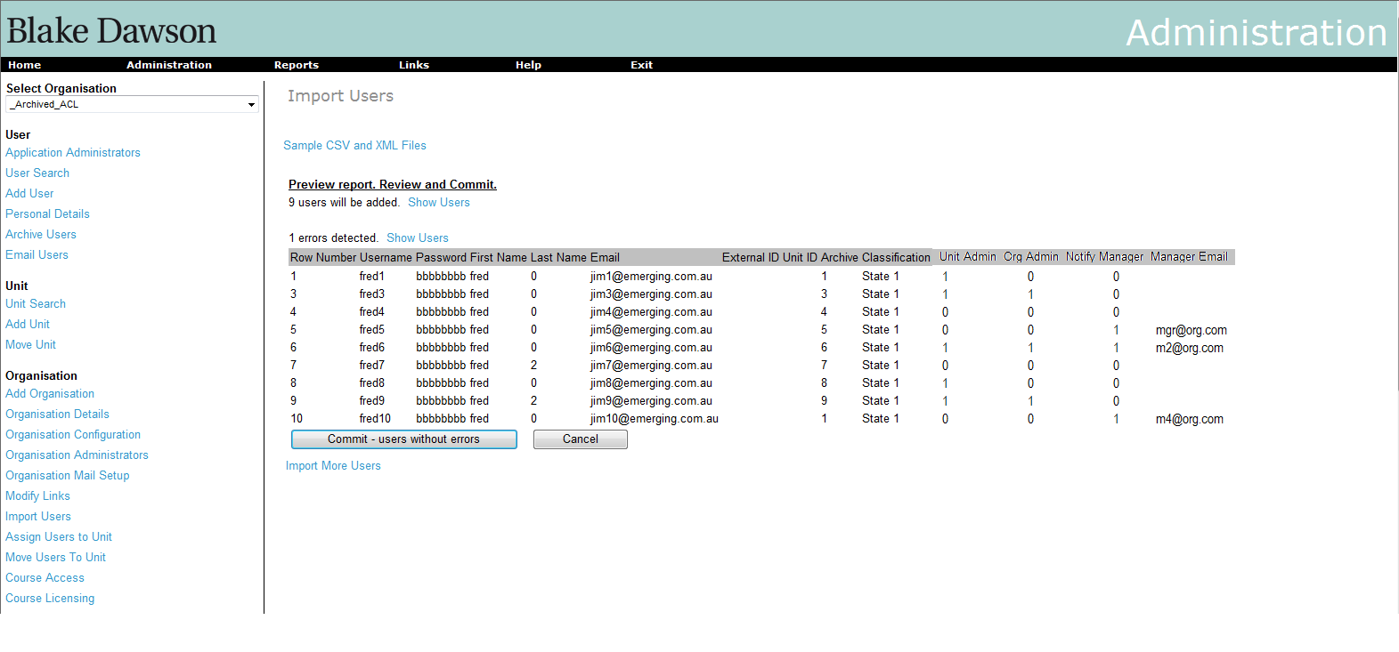

These new fields will also be added to the User Details screen. Only administrators will be able to see these new fields. Here is the screenshot of the modified User Details screen:

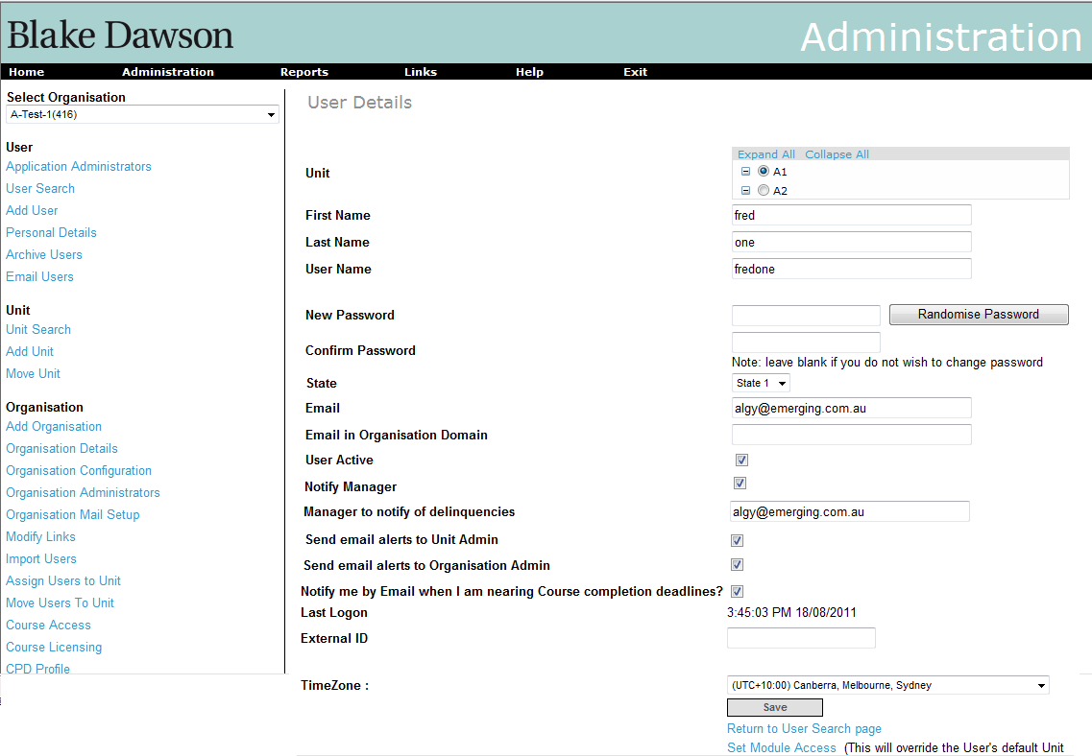

## 5.2 Behaviour of “Update Imports”

The functionality of the currently supported columns will remain the same as it is currently in SALT.

The additional functionalities will be as follows:

Currently only new users identified by the “unique field” can be added. However, now updating of existing users will also be supported. It is proposed that when two quote characters ‘’ are entered in a cel when editing the CSV file with excel the contents of the field will be deleted?

1. If a column is empty for an existing user then the value of this field will be maintained as it is currently there in the system and will not be overwritten.
2. If there is a value in a column for an existing user then the value of that field currently there in the system will be overwritten with the new value.
3. If there is a user in the imported file, which is not currently there in the system, then a new user will be created with the values of the fields as there in the imported file.
4. If there is a user in the imported file, which is currently there in the system, then the values of the fields for that user will be updated with the new values in the corresponding columns in the imported file.

In the preview screen, Instead of showing only the users that will be added and users that have errors in the import file, the users that will be updated will also be shown. The fields that are updated will be shown in a different colour. Below is a screenshot:

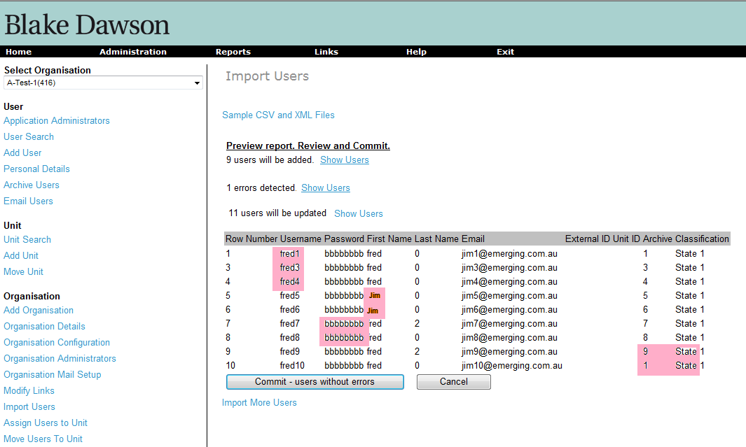

# 6. Modifications to “My Training” page

## Requirement:

The current “My Training” page shows the list of courses that are assigned to the user. It shows status i.e. whether the course has not been attempted, or is in progress, or has been completed. Please see the screenshot below:

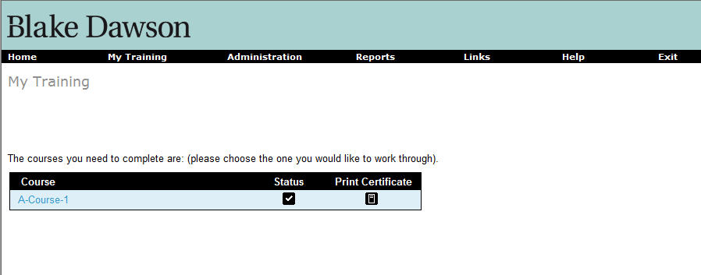

On clicking on the course the list of associated modules are displayed. The status of the lessons and quizzes in the modules are displayed as icons as shown below.

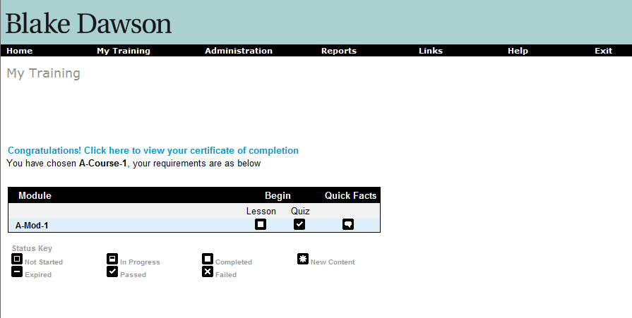

## Proposed modifications screens:

The “My Training” page with courses will show 2 more columns as shown in below screenshot. The “Due Date” column shows the date when the user is Overdue or the number of days until it becomes overdue. The colour of the text will be red and BOLD if the due date has passed. The “Last completion date” column shows the last date when the course was completed by the user. It is assumed that it will be useful to know when the certification for the course is expiring.

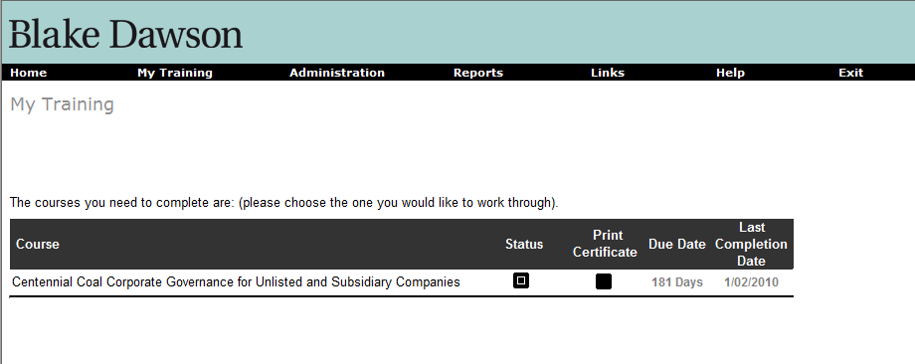

The “Modules” screen will have 2 more columns for the modules as shown below. The “Last pass date” will show the date when the user has last completed the module and passed the quiz. The “Quiz due” column will show the due date for passing the quiz or the number of days before it expires. The colour of the text will be red and BOLD if the due date is in the past.

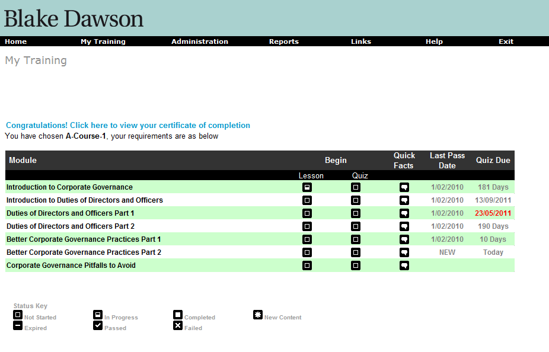

# 7. Provide a Rich Text editor on the existing “Org Config” screen

Requirement: Provide a Rich Text editor for each email template on the existing “Org Config” screen that allows org admins to define HTML email templates rather than just plain text email templates.

## Proposed Screens:

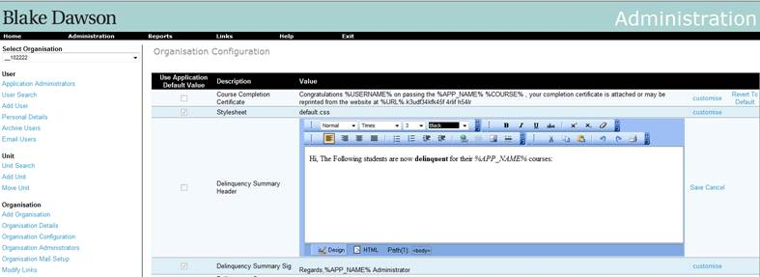

Figure 9 Organisation Config Screen (Editing - i.e editor visible)

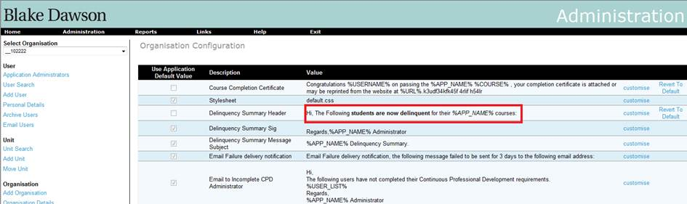

Figure 10 Organisation Config Screen (Not editing)

# Requirements

To add the ‘customise option’ for message that have already been customized:

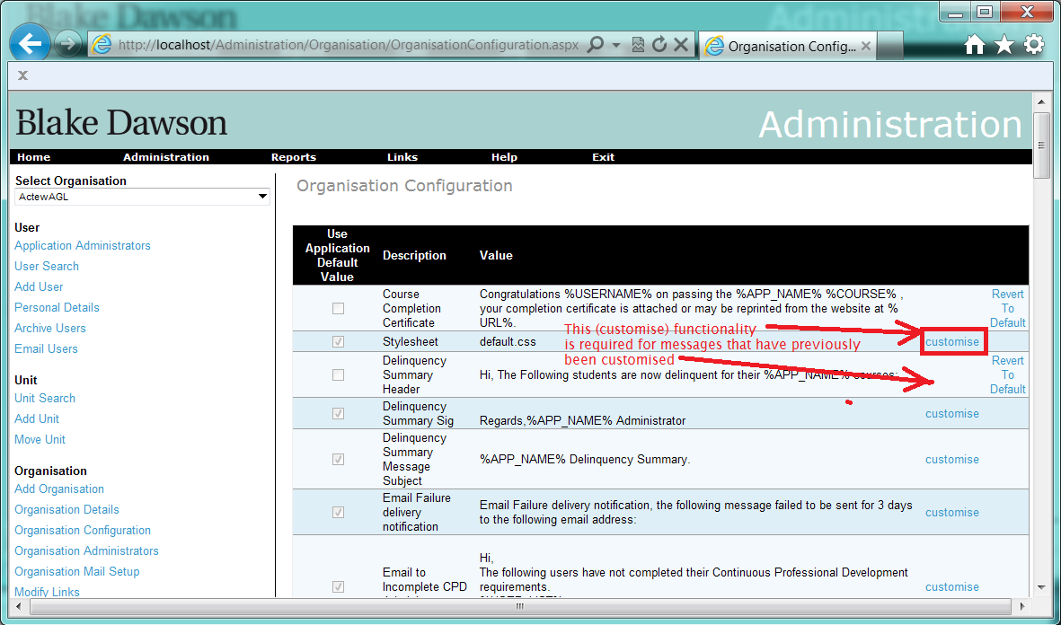

# Identified Risks

The risk is when the outcome is the condition where there are two versions of a customized message for one organization. In this case, several ASP pages may error on loading as the SQL on those pages is written to handle (at most) one customised message.

# 8. Ability to disable manager notifications at course level and to produce summaries or individual notifications.

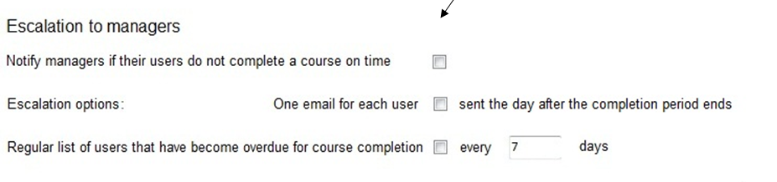

For each course in the Organisation the Administrator may define how the Overdue Emails will behave. The Manager may choose to have

* no Overdue emails sent
* One email per user
* A summary every N days

## 8.1 Ability to disable manager notifications

The Mail Queueing service will not create Overdue summaries for courses in the Organisation flagged as “no Overdue emails sent” however the service will set flags such that if the “no Overdue emails sent” is unset in the future the manager will not receive emails for the period when “no Overdue emails sent” was set.

## 8.2 Ability to modify notification options for each course

The default options will be for no notification for a course so the user must modify the “Course Expiry” Mail options for a course before managers will receive notifications for that course.

A separate email will always be sent for every course.

## 8.3 Ability to produce summaries or individual notifications.

The services will be modified to allow individual emails to be sent.

## Ability to produce summaries at frequencies other than one day.

# 9. Provide a feature that allows admins to temporarily stop emails.

Sometimes the number of emails being sent may be too much for the system to handle. In such scenario, the organisation admins and the SALT admin should be able to temporarily disable all emails either for the organisation or for the **entire** site.  This should not just stop the mail sending service, thereby allowing emails to queue up whilst it’s disabled, which may result in a mail storm when the sending service is re-enabled – it should delete all existing emails that are currently queued . This will apply not only for the emails send via “Mail sending service”, but also to the ad hoc emails sent by the application.

To enable this functionality, there will be a button on the “Organisation Mail Setup” screen for the Organisation admin to stop emails for their organisation. The screenshot for this is shown below:

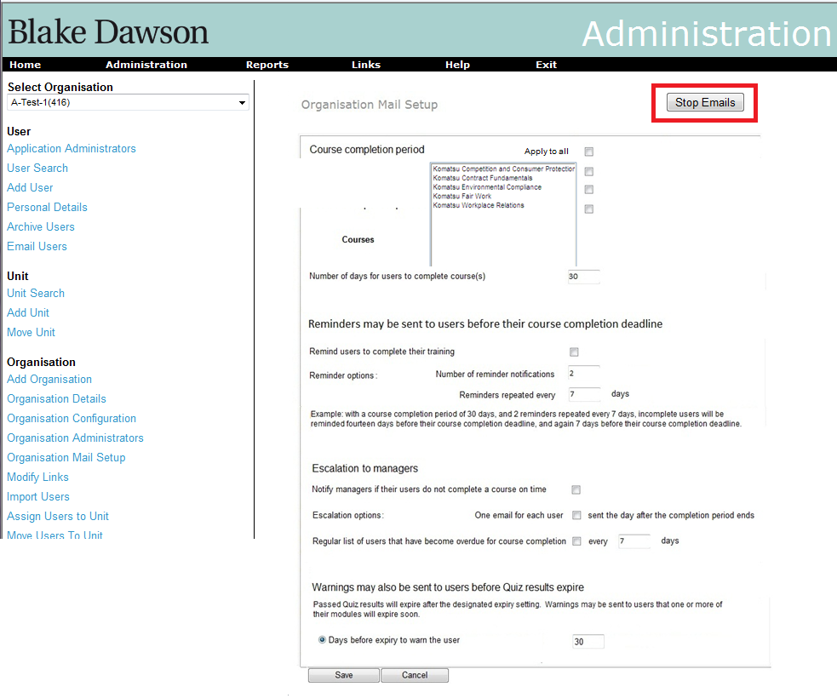

Along with this, the SALT admin will have an additional button on the “Mail Throughput” screen. This will stop all emails sent by the entire site (see the screenshot below).

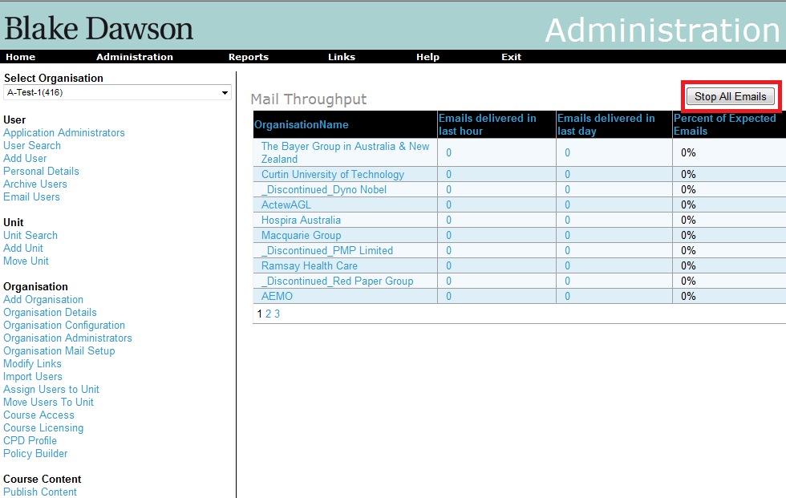

These buttons can be toggled, meaning once pressed they would provide option to enable sending the emails again.

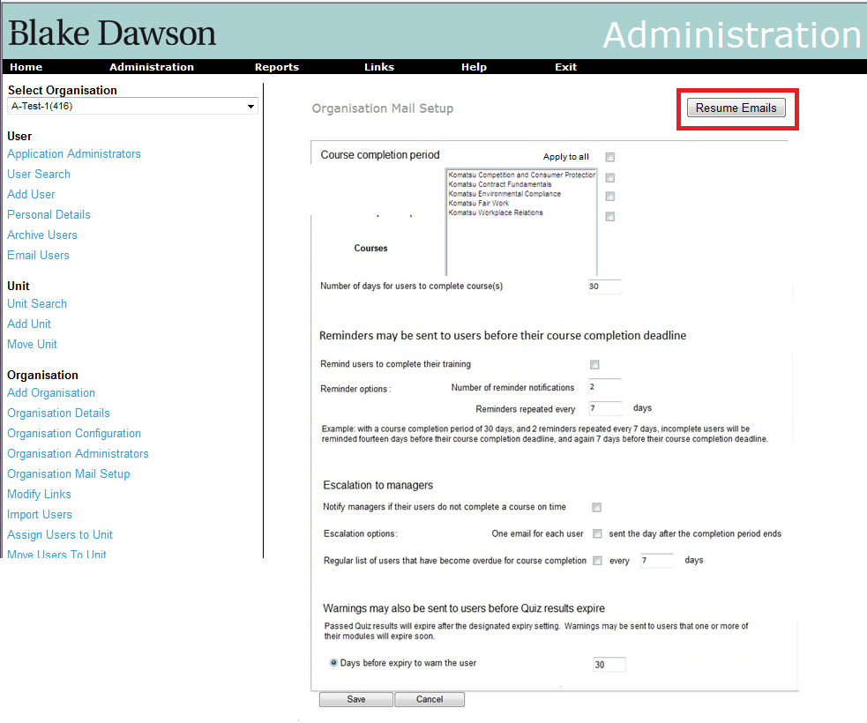

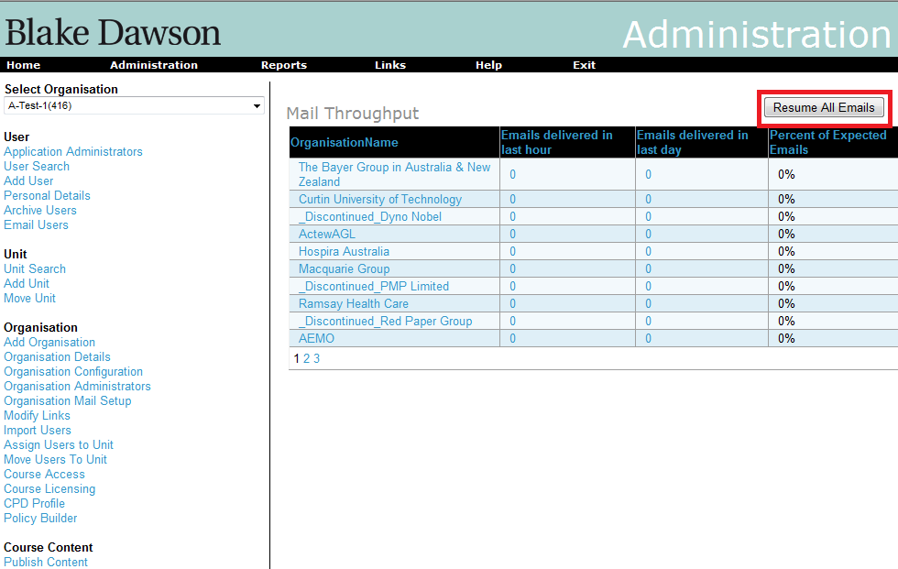

However, the dropped emails will not be re-sent. Even though emails will be created, queued and deleted from the application during this period when the “Stop Emails” button is pressed, they will be maintained in database for audit purpose.

# 10. Replace the user of the word “Delinquency” or “Delinquent” with ”Overdue”.

Requirement: Replace the user of the word “Delinquency” or “Delinquent” with Overdue.

# 11. reports are grouped by category

## Requirements

To modify the Salt4.2 Report menu so that reports are grouped by category as per the following table.

|  |  |
| --- | --- |
|  |  |
|  |  |
| **User Activity Reports** | |
|  | Current Admin Report |
|  | Course Status Report |
|  | Completed Users Report |
|  | At Risk Report |
|  | Warning Report |
|  | Progress Report |
|  | Historic Admin Report |
|  |  |
| **Organisation Reports** | |
|  | Summary Report |
|  | Trend Report |
|  |  |
| **Email Reports** | |
|  | Email Report |
|  | CPD Email Report |
|  | Policy Email Report |
|  | Sent Email Report |
|  |  |
| **Administration Reports** | |
|  | User Detail Report |
|  | Active / Inactive Users Report |
|  | Licensing Report |
|  | Unit Pathway Report |
|  | Unit Compliance Report |
|  | Unit Administrator Report |
|  |  |
| **CPD Reports** | |
|  | CPD Report |
|  |  |
| **Policy Reports** | |
|  | Policy Builder Report |
|  |  |

All category names will be localized (with the English version of the localization supplied)

When an Organisation does not have CPD access neither the “**CPD Reports**” category or the “CPD Report” link will be visible.

When an Organisation does not have Policy Builder access then neither the “**Policy Reports**” category or the “Policy Builder Report” link will be visible.

# Implementation

The 6 category names must be created in the localization tables for the GLOBAL.UserControls.ReportsMenu.ascx interface.

Changes will be made to ReportsMenu.ascx to display the labels.

Changes will be made to ReportsMenu.ascx.cs to hide the categories when they should not be visible.

# Testing

Testing should be done in all user contexts:

* Student
* Unit Admin
* Org Admin
* App Admin